
Short Manual
Sebastian Stumpf
sebastian.stumpf@unibe.ch

This short manual guides users through the core features of ICP-Base. If more explanations are needed, please conduct the extensive manual.
This software improves through user feedback.
If you still have questions, are in dire need of a custom feature, found a bug, want to collaborate or have a LA-ICP-MS system for which the import is not yet implemented – feel free to write me an email! If you found a bug, please try to reproduce it and include that in the email, it will make the fix much easier. If you want your LA-ICP-MS data to be importable or you cannot import yours even though it should work, make sure to include those files in the email as well.
Without feedback, issues can go unnoticed and useful features may not be considered.
Contributions, suggestions, and reports are always welcome.

Philosophy and data structure
This software is designed to integrate with your existing LA-ICP-MS data processing workflow while automatically building a structured database of all analyses. It stores raw data, quantification steps, final results, and metadata from both the LA and ICP-MS systems in a consistent format.
The metadata is stored separately and does not influence the quantification. It is retained for purposes such as long-term monitoring and method development.
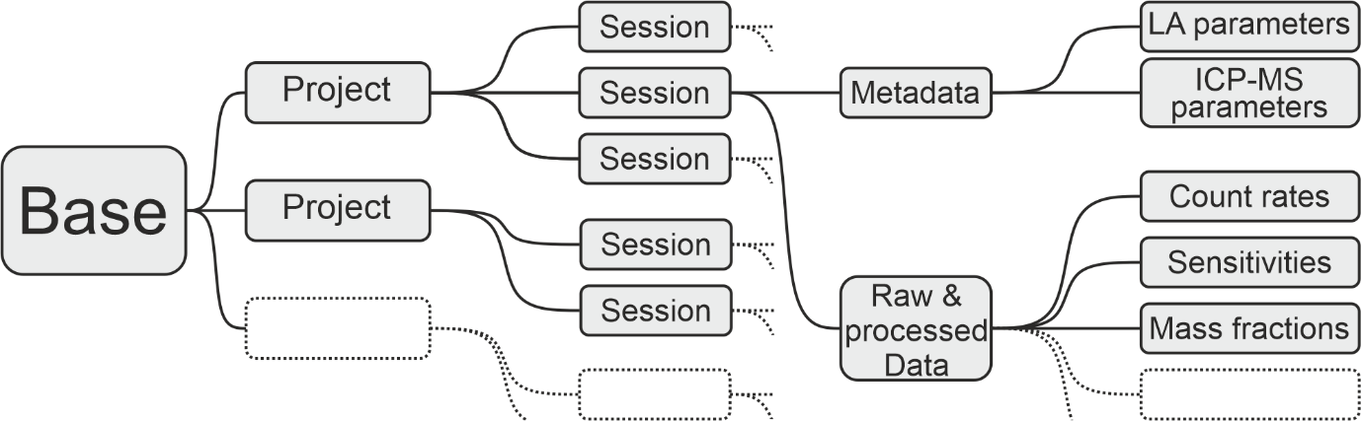

It is therefore strongly recommended to maintain a single Base that contains multiple Projects, each of which can include multiple Sessions. Using multiple Bases reduces the benefits of a centralized data structure and should be avoided.
The Base Module is the central hub from which all data can be accessed. When adding a new session, the linear quantification workflow is started and the software guides you through the processing steps.
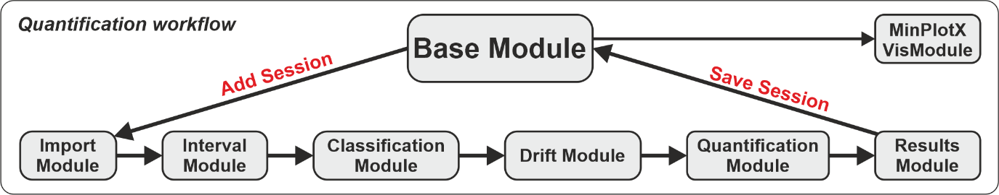

Base
- Add projects
  - Rename them by double-clicking the name
- Add sessions
  - Select project first
  - Starts the data processing
  - Rename by double-clicking the name
  - Add metadata (date etc)
- Import and export projects and sessions using the menu
- Save the base to your computer
- Proceed to VisModule
  - Table builder submodule lets you choose the data to visualize
    - Optionally export the table as .xlsx or .mat (right-click the button)

Import Module
In this module the data is imported and the signal starts and ends are detected.
- Import signal data files (raw counts-per-seconds data)
  - (Continuous) = One file for multiple spot analyses
    - Needs laser metadata to detect signals
  - (Single) = One file per spot analysis
    - Does not need laser metadata
    - Multiselect possible
    - For PerkinElmer .xl and Nexion .csv files the acquisition time is taken from the file information, if the file is changed and saved it again, this is wrong. For all other file types the acquisition time is stored in the file.
  - Agilent batch folder
    - Also imports ICP-MS metadata
    - One .d folder in batch folder ICP-Base assumes it’s “Continuous”
      - Needs laser metadata to detect signals
    - Multiple .d folders in batch folder ICP-Base assumes it’s “Single”
      - Does not need laser metadata
- Import laser metadata (“Logfiles”)
  - If “Single” the spot names get overwritten by the names in the logfile
  - If “Continuous” press the detect signals button on bottom left
    - Zoom in on the first signal on the plot to check if dashed lines align with signal starts and ends
      - If not type a global indent number (number where the first signal starts) in the field and press “Enter” on the keyboard to shift the dashed lines to signal starts and ends. Do this until it’s aligned.
- Import ICP-MS metadata
  - Optional
  - Dwell times are stored in:
    - Agilent AcqMethod.xml
    - Thermo Fisher Element XR (.FIN)
    - Thermo Fisher iCAP they are already imported with the signal data.
  - If no dwell times are imported, ICP-Base assumes 10 ms
    - This can be changed later in the Quantification Module
  - Machine specific parameters
    - Agilent AcqMethod.xml and HardwareConfig_XXX.xml
    - Thermo Fisher iCAP they are already imported with the signal data.
If you
- Imported all necessary/available data and
- detected the signal starts and ends correctly
You can proceed in:
- “Matrix Mode” for “normal” spot analysis
- “Inclusion Mode” for inclusion analysis
Additional features: Moving average interval setting

Interval Module
In this module, the spikes are eliminated, the integration intervals are set and in case of inclusion analysis the host-inclusion-mixed signal can be deconvolved.
- Spike elimination
  - Works spot-wise via 7 and 9-sweep window Grubbs’s test
  - Press “Spike Elimination” button
  - Right-click on button and press “Apply globally”
    - Same is possible to reset it
  - No spikes are eliminating in the inclusion intervals by the “Spike Elimination” button or the “Apply globally” option
    - Spikes in the inclusion intervals can be manually accepted or ignored via right-click on the “Spike elimination” button and then selecting “Individual (Inclusion only)”.
  - To manually accept or ignore all spikes select “Individual” after right-clicking the “Spike Elimination” button.
  - Change spike elimination settings in the menu on top
- Interval setting
  - Global Interval Setting
    - Changes the intervals globally
    - Depends on the signal start and end as detected in the Import Module
    - The numbers and ± 1, ±10 are the number of sweeps that are intend from the starts and ends
    - Also moves the intervals that were manually adjusted so watch out
    - By right-clicking on the “Set XY” buttons the intervals can be adjusted spot group wise
  - Local Interval Setting
    - Set intervals by dragging and dropping the cursor over the plot
    - In Inclusion Mode there is also the “Inclusion” interval
  - Manually moving intervals
    - Click, hold, drag and drop the middle or borders of the intervals to adjust them
    - This just changes the one interval that was moved
- Host-Inclusion Signal unmixing
  - Only in Inclusion Mode
  - Only visible when plotting background-corrected
  - Matrix-only tracer
    - Choose element and spot to take the host from
  - Two internal standards
    - Values are input in Quantification Module
- Plot styles
  - Make them yourself
    - Navigate to ICP-Base folder
    - Get subfolder “Plot_Styles”
    - Based on .csv files
      - Open/Delete/Change the plot styles
      - Also able to plot ratios
  - Right-click on the top right list box
    - Press “Refresh” to load in new or changed plot style
- General visualization features
  - If the built-in zoom function is used (top-right icons in the plot) make sure to deselect the zoom function by clicking on it again. Otherwise you cannot move the intervals anymore.
If you
1. Eliminated the spikes,
2. set the integration intervals and
3. in case of inclusion analysis chose a method of unmixing
You can proceed to the Classification Module

Additional features: Spike elimination report, Change Plot Styles folder path, add comments to spots

Classification Module
In this module, the spots are assigned roles
- Types
  - “Unknown” is an unknown that should be quantified
  - “In-House Standard” (IHRM) is an unknown that gets measured repeatedly to be compare to itself.
  - “Quality Control Reference Material” (QCRM) is treated like an unknown but has a known composition to which the results can be compared to.
  - “Calibrator” (CAL) is actually used for the quantification of the other types.
- Reference Materials
  - Their compositions are stored in files in the subfolder RM_Files in the ICP-Base folder or in a custom set filepath (changed via the settings menu).
  - Add/Change/Delete them as you like
    - Press “Get RM files” to import the RM files from the folder
- Assign types and reference materials to the spots by selecting them directly in the table or via string search
- Assign bracket ids if you measured the same reference material with e.g. different spot sizes to separate them.
  - Different reference materials do not have to be separated by the different bracket ids. They are already separated by the fact that they are different reference materials
  - Bracket ids only should be used to separate spots of the same reference material
- Right click on a table row where an RM was assigned to look at the reference values of that RM.

If you
1. Classified each spot has a role and
2. separated the CAL via bracket id (if necessary)
You can proceed to the Drift Module

Drift Module
In this module, you cannot give any input in the software. The drift is calculated for you in a fixed manner. All you have to do is look and think!
- The plot visualizes the drift of the sensitivities of all analytes of a given calibrator and bracket id pair
  - The dots are the sensitivities (vertical axis)
  - Horizontal axis is time
- Using the dropdown menus at the top you can navigate through the calibrator and bracket id pairs.
- Line colors
  - A blue line means that the sensitivity of a given analyte changed less than 5 % from the start of the bracket to the end of the bracket.
  - Orange indicates a change of 5 to 10 %.
  - Red shows a change of more than 10 %.
- If a standard measurement is off, you can go back to the Interval Module and delete this standard’s integration intervals to disregard it.

If you
1. Looked at the Drift and evaluated it
You can proceed to the Quantification Module

Quantification Module
In this module, the internal standards are input.
- One can choose between (i) a known mass fraction of a single analyte or (ii) a normalization to a given sum of total oxides
- Assign them using a direct selection on the table or string search
  - String search can also do && (and) and || (or)
    - E.g. “amp && micas” will select all spots containing “amp” and “micas”
- Make sure to do this for all PRM – bracket id pairs that were previously defined in the classification module (change dropdowns on the top)
  - For individual spot measurements without an information on internal standardization, nothing "bad" happens, ICP-Base will just not quantify this measurement spot
- Inclusion Quantification
  - Choose “Inclusion” or “Host” in the dropdown menu top right and enter you internal standards.
  - Everything else works pretty much the same
- Sequential quantification
  - First input the internal standards for the first PRM (let us call it XY) that should be used for quantification
  - If a spot is bracketed by multiple PRMs, you can go to another PRM (let us call it Z), select an analyte (let us say Si29) and then click on the “µg/g” column and select “from XY”
  - So defined, ICP-Base first quantifies the spots using PRM XY. Then the result of Si29 of this first quantification will be used as the internal standard for the quantification of the same measurement spots using PRM Z.
  - This can be done with multiple standards, just be careful in defining the successive steps involved in this quantification strategy
- Adjust dwell times if necessary
  - Open the dwell times using the “Show Dwell Times” button
  - Change the value (in seconds) and close again
If you
1. Entered the internal standards
You can proceed to the Results Module

Additional features: MSF, Sequential Quantification (from XY feature)

Results Module
This module shows the results, compared SRMs to reference values and makes it possible to add metadata to the spots
- Raw results
  - Show the results of a selected PRM – bracket id pair
    - Mass fractions
    - Mass fractions unfiltered (without detection limits)
    - Sensitivities
    - CPS
    - And more
  - Change to “Inclusion” to see results for inclusion
  - Create an output table
    - It will always output the table that you are currently looking at
    - Right-click the button to output the mass fractions for all PRM – bracket id pairs
- Add Metadata
  - Add sample names and materials and location
  - Add custom columns (numeric or text)
- Quality Control
  - Secondary Reference Material
    - Ratios the results of a secondary reference material by its “Real Value” which comes from the reference material file (.csv in RM_Files folder)
  - Matrix sensitivity factor
    - Same as in the Quantification Module, read it up there
  - Session Drift
    - Shows the results over the time of the session
    - For secondary reference materials there is a black dashed line to show the “real value”
    - Grey dashed lines show that there were some other spots measured in between
If you
- Got the results,
- Evaluated the SRMs,
- Added Metadata (optional)
- Created output tables
You can end the data processing.

